《湖南中医药大学学报》英语摘要撰写指南

- 中医药相关术语请参照WHO（2022）中医药术语标准（附PDF文件）或中医术语在线（免费免注册网站）https://ist.shutcm.edu.cn/#/home。
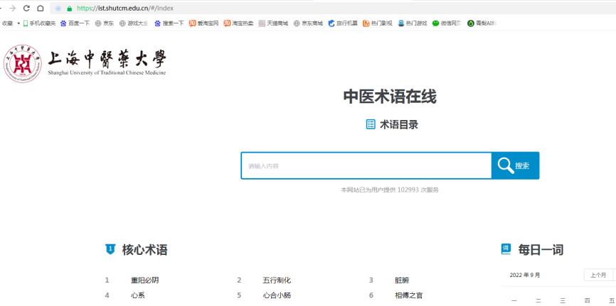

- 翻译后的文本请登陆
Online Text Correction https://www.onlinecorrection.com/ （免费免注册网站）检查语法错误。

第一步：打开网站，将文本复制进入框内。
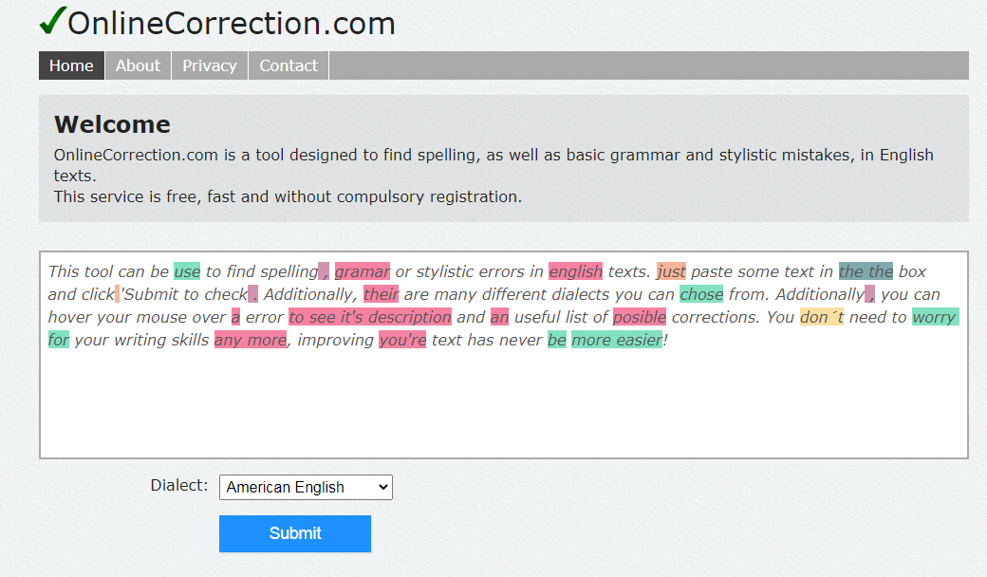

第二步：默认American English， 点击 submit键提交。
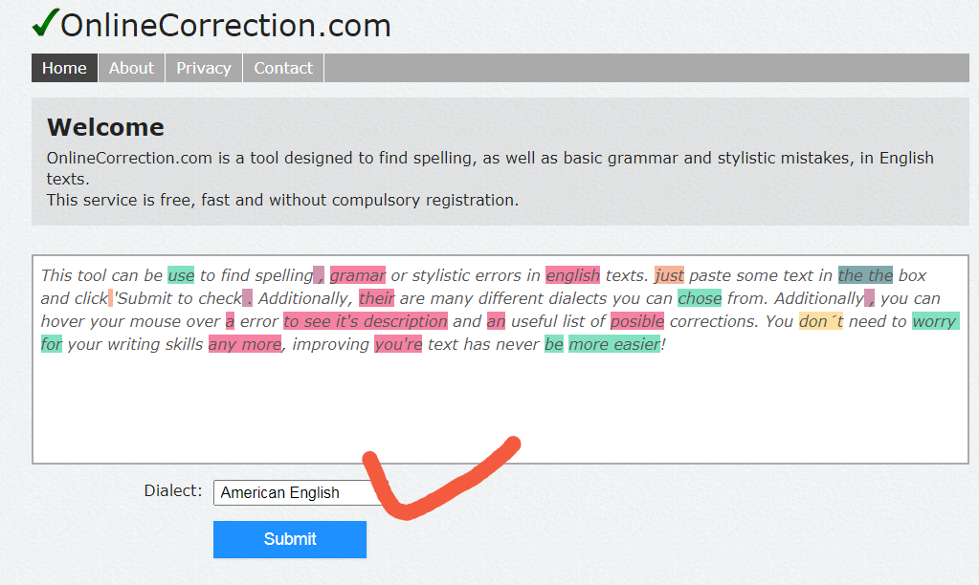
第三步： 根据显示结果（绿色：语法错误；红色：拼写错误；橙色：排版错误；紫色：拼写错误），进行修改。
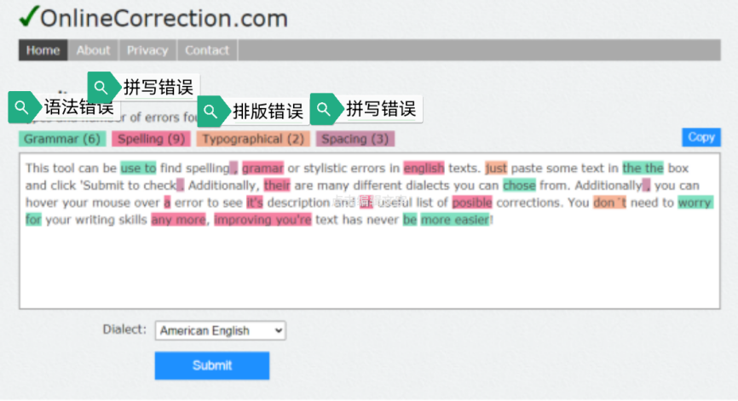
- 英文摘要(Abstract)内容及关键词(Keywords)应与中文部分内容保持一致。

4、部分格式要求
姓名：ZOU Lijuan 穴位名：Zusanli (ST36)
中成药名：Guizhi Fuling Pill
中药名：Qiancao (Radix Rubiae Cordifoliae)
典籍名：Wen Bing Tiao Bian (Systematic Differentiation of Warm Diseases)

附结构式摘要范本：
Effects of Guizhi Fuling Pill on ... in patients with ulcerative colitis
LIU Jie, WANG Liman...
(Department of ×××, ××× Hospital of Chinese Medicine, Changsha, Hunan 410006, China)
[Abstract] Objective To investigate the effects .... Methods A total of 96 patients with UC of damp-heat of large intestine were randomly divided into... Results The TCM syndrome score, DAI score and Geboe index ... Conclusion Guizhi Fuling Pill can...
[Keywords] ulcerative colitis; damp-heat of large intestine...

